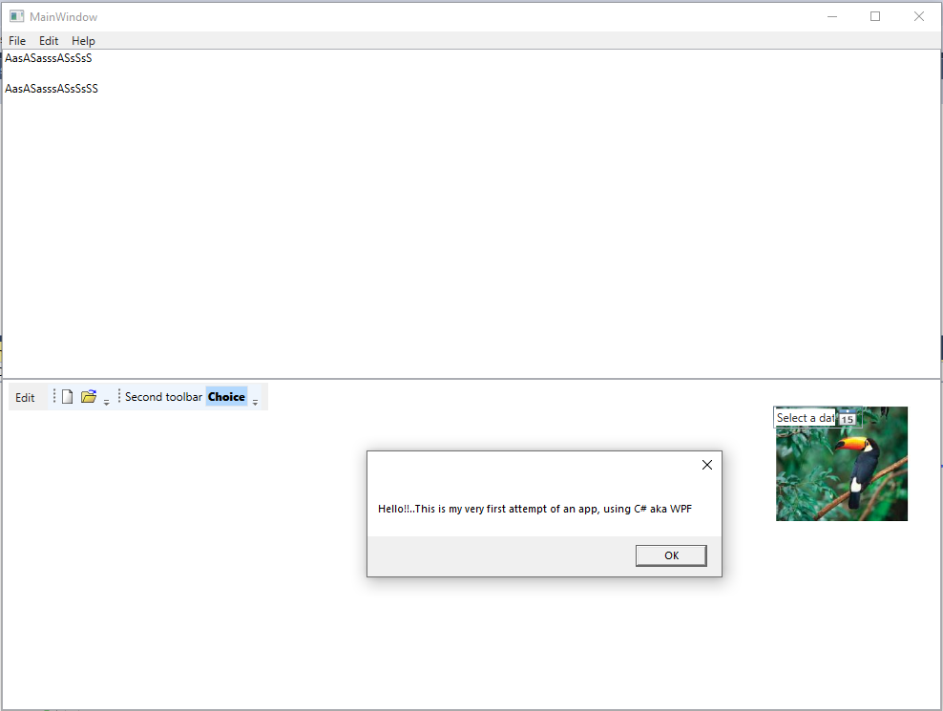

Source codes: **Programming WPF (Book)**

**2. MainWindow.xaml (CODE)**

<Window x:Class="WpfApp1.MainWindow"

xmlns="http://schemas.microsoft.com/winfx/2006/xaml/presentation"

xmlns:x="http://schemas.microsoft.com/winfx/2006/xaml"

xmlns:d="http://schemas.microsoft.com/expression/blend/2008"

xmlns:mc="http://schemas.openxmlformats.org/markup-compatibility/2006"

xmlns:local="clr-namespace:WpfApp1"

mc:Ignorable="d"

Title="MainWindow" Height="750" Width="1000">

<Grid>

<Grid.RowDefinitions>

<RowDefinition Height="Auto" />

<RowDefinition />

<RowDefinition />

</Grid.RowDefinitions>

<Menu>

<MenuItem Header="_File">

<MenuItem Header="_New" />

<MenuItem Header="_Open..." />

<MenuItem Header="_Save" />

<MenuItem Header="Sa_ve As..." />

<Separator />

<MenuItem Header="Page Se_tup..." />

<MenuItem Header="_Print..." />

<Separator />

<MenuItem Header="E_xit" />

</MenuItem>

<MenuItem Header="_Edit">

<MenuItem Header="_Undo" />

<MenuItem Header="_Redo" />

<Separator />

<MenuItem Header="Cu_t" />

<MenuItem Header="_Copy" />

<MenuItem Header="_Paste" />

<MenuItem Header="_Delete" />

<Separator />

<MenuItem Header="Select _All" />

</MenuItem>

<MenuItem Header="_Help">

<MenuItem Header="Help _Topics" />

<MenuItem Header="_About..." />

</MenuItem>

</Menu>

<TextBox Grid.Row="1" AcceptsReturn="True" />

<ListBox Grid.Row="2" SelectionChanged="ListBox_SelectionChanged">

<Menu Grid.Row="0">

<MenuItem Header="_Edit">

<MenuItem Header="Cu_t" Command="ApplicationCommands.Cut" />

<MenuItem Header="_Copy" Command="ApplicationCommands.Copy" />

<MenuItem Header="_Paste" Command="ApplicationCommands.Paste" />

</MenuItem>

<ToolBarTray>

<ToolBar>

<Button>

<Canvas Width="16" Height="16" SnapsToDevicePixels="True">

<Polygon Stroke="Black" StrokeThickness="0.5"

Points="2.5,1.5 9.5,1.5 12.5,4.5 12.5,15 2.5,15">

<Polygon.Fill>

<LinearGradientBrush StartPoint="1,1" EndPoint="0.2,0.7">

<GradientStop Offset="0" Color="#AAA" />

<GradientStop Offset="1" Color="White" />

</LinearGradientBrush>

</Polygon.Fill>

</Polygon>

<Polygon Stroke="Black" Fill="DarkGray" StrokeThickness="0.5"

StrokeLineJoin="Bevel"

Points="9.5,1.5 9.5,4.5 12.5,4.5" />

</Canvas>

</Button>

<Button>

<Canvas Width="16" Height="16" >

<Polygon Stroke="Black" StrokeThickness="0.5" Fill="Khaki"

SnapsToDevicePixels="True"

Points="0.5,14.5 0.5,4.5 1.5,3.5 6.5,3.5 8.5,5.5

12.5,5.5 12.5,14.5" />

<Polygon Stroke="Black" SnapsToDevicePixels="True"

StrokeThickness="0.5"

Points="1.5,14.5 4.5,7.5 15.5,7.5 12.5,14.5" >

<Polygon.Fill>

<LinearGradientBrush StartPoint="0.25,0" EndPoint="0.5,1">

<GradientStop Offset="0" Color="#FF4" />

<GradientStop Offset="1" Color="#CA7" />

</LinearGradientBrush>

</Polygon.Fill>

</Polygon>

<Path Stroke="Blue" StrokeThickness="1"

Data="M 8,2 C 9,1 12,1 14,3" />

<Polygon Fill="Blue" Points="15,1 15.5,4.5 12,4" />

</Canvas>

</Button>

</ToolBar>

<ToolBar>

<Button>Second toolbar</Button>

<CheckBox IsChecked="False" VerticalAlignment="Top" Height="22" Checked="CheckBox_Checked_1" FontFamily="Segoe UI Black">Choice</CheckBox>

</ToolBar>

</ToolBarTray>

</Menu>

</ListBox>

<Image Margin="808,28,29,198" Grid.Row="2" Source="toucan.jpg"/>

<DatePicker Margin="808,28,82,295" Grid.Row="2"/>

</Grid>

</Window>

**3. MainWindow.xaml.cs (CODE)**

using System;

using System.Collections.Generic;

using System.Linq;

using System.Text;

using System.Threading.Tasks;

using System.Windows;

using System.Windows.Controls;

using System.Windows.Data;

using System.Windows.Documents;

using System.Windows.Input;

using System.Windows.Media;

using System.Windows.Media.Imaging;

using System.Windows.Navigation;

using System.Windows.Shapes;

namespace WpfApp1

{

/// <summary>

/// Interaction logic for MainWindow.xaml

/// </summary>

public partial class MainWindow : Window

{

public MainWindow()

{

InitializeComponent();

}

private void CheckBox_Checked(object sender, RoutedEventArgs e)

{

}

private void CheckBox_Checked_1(object sender, RoutedEventArgs e)

{

MessageBox.Show("Hello!!..This is my very first attempt of an app, using C# aka WPF");

}

private void ListBox_SelectionChanged(object sender, SelectionChangedEventArgs e)

{

}

}

}